**Video making for Anodiam**

**Technical aspects** :

### Lighting –

Step 1: Prepare for the shoot. It's a good idea to scout your location ahead of time.

Step 2: Pick out your lighting options and types. There are a few types of lighting to be aware of as well. Light with no filter is known as hard light. Diffusion helps spread light evenly, creating soft light, and can be improvised even on a budget. So when working with clamps lights, it is highly suggested using some type of diffusion material.

These lights can also be bounced off a surface like a wall, ceiling, or reflector to create soft light, which is infinitely preferable to blinding your subject and creating an unflattering image.

Step 3: Set up 3-point lighting. This configuration consists of a key light, a fill light, and a backlight which can also be called a hairlight.

The **key light** should be the brightest of the three and provides the bulk of light to your subject.

The **fill light** eliminates shadows caused by the key light. Your fill should be less intense than your key so while it still eliminates shadows, but doesn’t a [flat looking shot](https://photo.stackexchange.com/questions/15579/what-is-flat-light-and-how-to-counter-that) due to the fill and key lights matching too closely.

**The backlight** separates your subject from the background, creating depth and also preventing a flat looking shot. Your backlight can be hard light (no diffusion), as it won’t create shadows visible to the camera on the subject’s face. 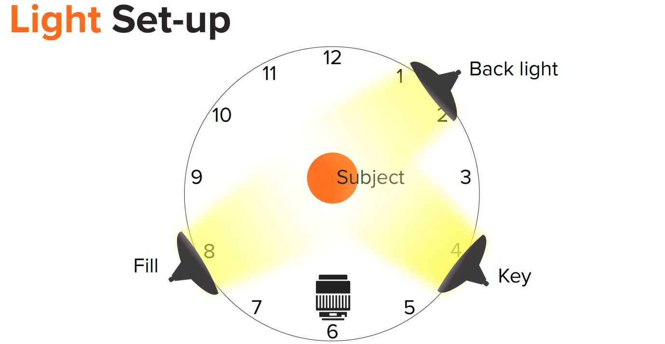 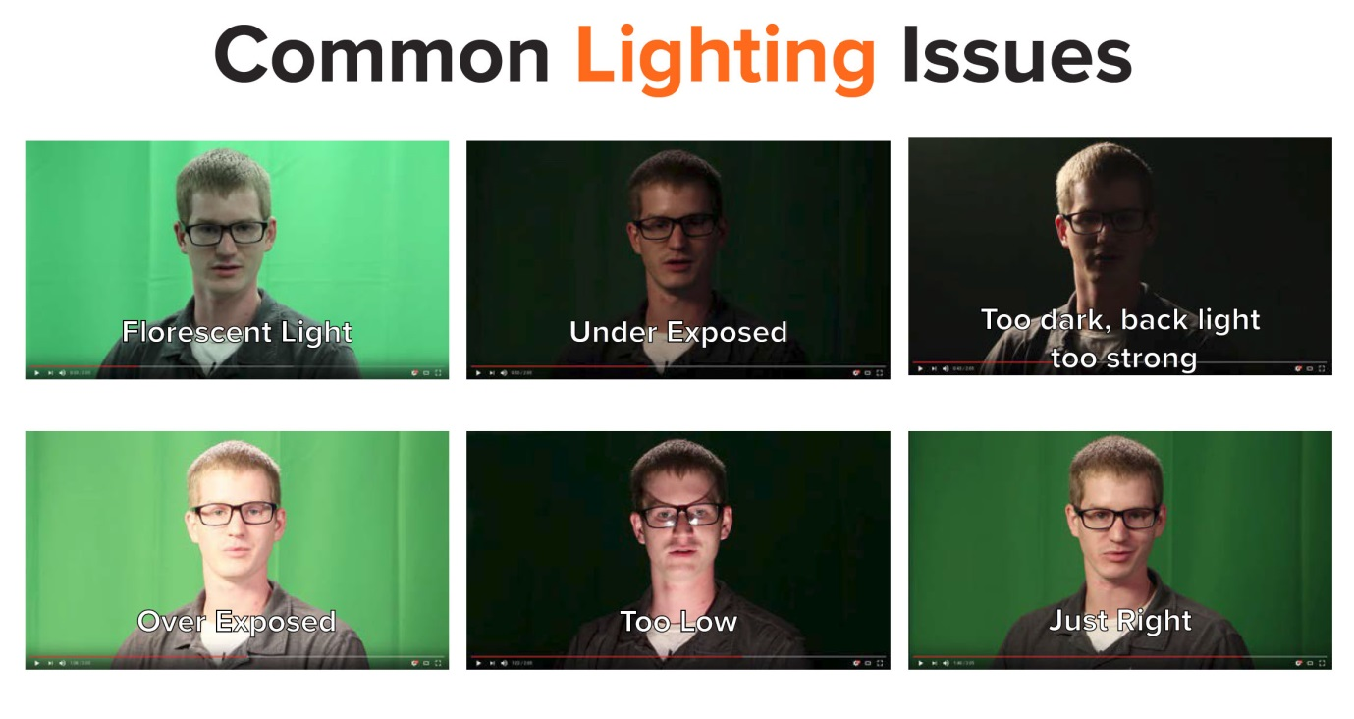

Step 4: Choose your light color temperature. Not all lights are created equal. Based on the filament in the bulb, lights can appear “cooler” or “warmer” on camera. This is perceivable with the human eye as well.

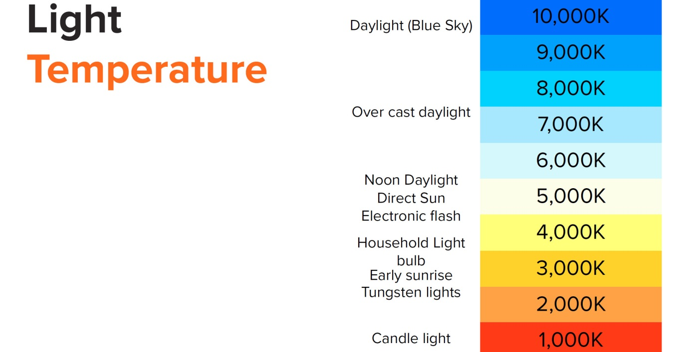

Step 5: Look out for glare. Glasses wearers, while generally considered to be amicable and friendly folks, can be your worst enemy when it comes to lighting.

Glare on glasses can be a big issue, especially lights with larger diffusion boxes.

One trick that helps with glasses is raising up your lights higher on their stands. If you have someone who can assist, have them raise the lights and look through the camera viewfinder until the light is no longer visible in the glasses lens. If raising the lights doesn’t help, try moving your key and fill lights farther out, while keeping them relatively equal to one another.

In the 3-point lighting image above, your key would be closer to 3:15 and your fill would be 8:45.

(Ref : https://www.techsmith.com/blog/get-perfect-lighting-video/)

**Sound** - At the foundation, good sound means capturing clean audio at an acceptable recording level, so that your audience understands what your video is communicating. But good sound is actually much more than that: it involves thoughtfully planning your shoots with sound in mind. This process starts when you’re selecting your location. Research your [locations](https://creatoracademy.youtube.com/page/lesson/production-workflow?hl=en) to avoid unpleasant surprises. And if you’re inside, consider the room’s acoustics and noises that electronics or other elements might create.

Good sound can significantly impact how viewers experience your video. Audiences are typically more forgiving of camera and lighting mistakes than they are of poor sound quality and recording.

* Shotgun microphones are the most highly directional. They are most readily used with most YouTube formats, including video blogs.

If you’re on a budget and recording with your smartphone, you can find free apps and low-cost compact external mics that help you capture better sound ([listen to a few samples](https://www.youtube.com/watch?v=CcZJEuTF0ec)). For other situations, you might actually want a combination of mics, especially if you’re trying to isolate sound from specific sources. There are things you can do to enhance your recording conditions. If you’re inside, try padding your space with sound blankets and foam to cut down on excess echo. Avoid recording near noisy refrigerators and air conditioners, and remember to silence your electronic devices, which could potentially interrupt your recording. Here are a few more tips for recording like a pro:

* Check the connection from your mic to your camera’s audio input. Also confirm if your mic requires a separate power source.
* Keep the mic positioned close to the desired audio source (your mouth when speaking). And project your voice strongly—but don’t yell.
* Have someone monitor the sound while recording (through headphones). If it’s just you, do a test run and play it back to yourself.

### Camera position Where to Look -

To look good on camera, you should always look at the camera when you’re speaking (unless you’re doing an interview). Memorization is tough, so instead, shoot video in bursts. This is the process of shooting small chunks together in small bursts, looking away to remember your lines, bursting again, and so on. You can edit it all together seamlessly afterwards. With bursting you can look at notes and then back to the camera again and your audience will never know. The key to bursting is to be very punctuated in your movements, facial expressions, or gestures– leaning in for this line, gesturing with your hand in another line, etc.

Teaching aspects :

**Presentability -** You can follow the seven tips below to look good in your next video.

1. Be Energetic. A camera can be the biggest critic you ever meet. It seems when you display a low energy level and does not miss a beat when your enthusiasm stretches the truth.
2. Make the topic understandable. Studies show that our attention span today is only [8 seconds](http://time.com/3858309/attention-spans-goldfish/). To keep your audience hooked to your video, you need a quick and clear message.
3. Remember to smile. [72%](http://www.littlethingsmatter.com/blog/2010/07/19/the-ripple-effect-of-a-smile/) of people believe that frequent smilers are secure and successful. What better way to win your audience’s trust than by showing that you are confident about your business and services.
4. Look directly into the camera. The challenge is that speaking in front of a live audience is different from talking on camera. First, you cannot gauge the emotions of the viewer. Second, you have a more limited range of motion. the camera lens scope limits you where you can look to ensure you capture the audiences’ attention. The key is to look directly at the camera lens. While it is tempting to look at yourself talking (depending on the camera in use) or focus on different spots throughout the video, your audience is only right in front of you.
5. Grab the audience attention early. We cannot repeat this statement enough; you have 8 seconds. Now that you have a clear message, you need a quick, clear way to convey your thoughts to your audience. The better you start your video; the more people will watch the rest. For example, don’t start by telling your name and the title of the video. Instead, come up with something compelling to your audience that immediately engrosses your viewer in your topic.
6. That could be an anecdote, statistic, or a bold claim (which you then back up).
7. You, viewers, need a reason to keep listening to your podcast or watch your video. You need to give them that reason early, or they will stop watching.
8. Take heed of the limited space of the camera and focus on it instead of looking around.
9. Prepare for your on-camera presentation. Depending on how much guidance you need before shooting the video, you might want to create an outline or script. Then practice the video until you are tired of hearing your voice. However, the moment you go on camera, your presentation will seem natural and conversational.
10. Make sure you dress for success. The adage is true: if you look good, you feel good. You do not need to spend your entire day getting dressed. However, you can spend some time finding a clean, ironed shirt to wear. For women any ethnic or western outfit is good which goes with her personality.
11. If you are not able to implement all of the tips immediately, start with the one or two tips you need to use the most to make your videos effective. Once you improve the weakest component of your videos, you can focus on other areas.
12. Then you will look good (and credible), so your audience wants to watch more of your videos and learn more about your services.
13. It’s important to smile the entire time you’re on camera. It might feel unnatural, but you have to make a conscious effort, because today’s video quality is High Def and in some cases 4K. That means that even a non-smile looks like a frown. If you watch TV commercials and interviews you’ll notice that the on-screen talent always has a pleasant look on their face. You need to look amiable to appeal to the widest base of clients.

**Voice modulation -** Voice modulation is one of the most powerful weapons that you can have in your arsenal while delivering a speech. Not only does it reflect confidence but it also helps in convincing your audience about your beliefs or ideas. This is the power that voice modulation commands over people!

1. Be Loud and Clear. Being loud does't mean that you have to shout. There is a difference. Make sure that your voice doesn't creak while being loud. This can irritate/annoy the audience and make them lose interest.
2. Practise Variation. You can look up for some steps that you can practise in order to develop the desired voice. You can look up for some steps that you can practise in order to develop the desired voice.
3. Practice speaking with variations in your speech. Let's go back to the time when we used to sing rhymes, or when our teacher used to tell us stories. Remember, only the variation in your tone can convey your expressions. Make your speech sound interesting to the people listening to it.
4. Stress on Powerful Words. Words don't create an impact, unless they are rightly delivered. You can take effective pauses, stress on a certain set of words, which will help your speech sound more interactive.
5. Create a Crowd Pleasing Speech. Connect with the audience. Speakers should use tools like humour, story and experiences to attract the crowd. The audience should be able to connect with you, right when you start your speech. You can even appreciate them for being a good audience, or ask them a few questions so that it gets you closer to them. Entertain your audience with a story that they can relate with. However, you need to keep in mind that the story should convey a message/moral to them. Narrating irrelevant stories will only distract them.Effective Pauses. ...
6. Sound Enthusiastic and Confident. Pauses are very important. They build curiosity in the minds of the people listening to you. You have to ensure that you don't take very long pauses, boring the audience instead. Have a clear idea of what you're about to speak. This will help you build a roadmap in your own mind regarding the speech and hence you will not forget your content

There are 2 effective pauses I would like to share with you:

1. A pause right after your introduction, while moving to emphasise on a certain idea will be really effective.

2. A pause while moving from one topic to another.

### Avoid Ahs and Uhms -

This can really irritate the audience while listening to the speaker, if he tends to keep on adding fillers like ahs and uhms over and over again. To avoid such fillers, you need to practise speaking a lot.

Sound Enthusiastic and Confident

The audience is seeking a hero in you, when you are speaking. DO not sound lousy, monotonous or use the same variation of tone in your speech. Display enthusiasm in your words.

Best of luck!!

**Screen grab software - <https://fluvid.com/?utm_source=GoogleAds&utm_medium=Fluvid&utm_campaign=Fluvid&gclid=Cj0KCQiA7qP9BRCLARIsABDaZzjKTiBTwvWg13ACoTAsqRu6n2TWYGroy3d-l8X3vJ08R-pOWB0FUj8aAueIEALw_wcB> (Fluvid free video capturing software)**

[**https://www.nchsoftware.com/capture/tutorial.html?kw=free%20download%20screen%20capture%20software&gclid=Cj0KCQiA7qP9BRCLARIsABDaZzjSksfaXT1lebskvC90crO9w8bIzd95dtd4jVA9DFTwTYpvw50sumUaAmRDEALw_wcB**](https://www.nchsoftware.com/capture/tutorial.html?kw=free%20download%20screen%20capture%20software&gclid=Cj0KCQiA7qP9BRCLARIsABDaZzjSksfaXT1lebskvC90crO9w8bIzd95dtd4jVA9DFTwTYpvw50sumUaAmRDEALw_wcB) **(debut video capturing software tutorial)**

[**https://www.nchsoftware.com/videopad/index.html?kw=free%20download%20screen%20capture%20software&gclid=Cj0KCQiA7qP9BRCLARIsABDaZzjzLDCcbr21DWBAZIaQSjlk-sP2qWRbvl6Lb1E1P3GC6RlLZQpQ64oaAr1kEALw_wcB**](https://www.nchsoftware.com/videopad/index.html?kw=free%20download%20screen%20capture%20software&gclid=Cj0KCQiA7qP9BRCLARIsABDaZzjzLDCcbr21DWBAZIaQSjlk-sP2qWRbvl6Lb1E1P3GC6RlLZQpQ64oaAr1kEALw_wcB) **(video editor)**

**Top Free Screen and Video Capture Software**

* Snagit. (2,678)4.6 out of 5. Entry Level Price:$49.99. ...
* CloudApp. (828)4.7 out of 5. ...
* Camtasia. (435)4.5 out of 5. ...
* Droplr. (390)4.5 out of 5. ...
* ConnectWise Control. (412)4.7 out of 5. ...
* Loom. (71)4.6 out of 5. ...
* Movavi Screen Recorder. (44)4.5 out of 5. ...
* screenflow. (44)4.6 out of 5.

**Video length** - 6 minutes

Nearly all experts firmly believe that training videos should be as long as they need to be in order to meet learning objective; however, research suggests that 6 minutes is the optimal length for instructional videos.

### Keep videos brief and targeted on learning goals. Use audio and visual elements to convey appropriate parts of an explanation; consider how to make these elements complementary rather than redundant. Use signaling to highlight important ideas or concepts. Use a conversational, enthusiastic style to enhance engagement.

### Miscellaneous

### Brand Anodiam theme intigration

### Engaging videos

### Dress code

### Make up

### Customer centric

### Content quality

### Subject matter depth

### Syllabus coverage

### Developing the personal connection with the students

### Follow up with the students

### Professionalism

### Language decorum

### Working with children norms